U N I F I E D M E C H A N I C S · P A P E R
Field Assembly and
Lossless Transcription

Why a field must be translated as an evolving logic,
not reconstructed from completed parts

JOSEPH SHIELDS
THE CROWLEY–GLORPNORP TRANSMISSION PROBLEM · CORPUS EDITION · 2026

On the grades.
PROVED follows from the definitions and assumptions stated in the paper. CONDITIONAL follows once a named condition is granted. PROPOSED is the Unified Mechanics interpretation offered for calculation and falsification. The paper does not treat these grades as interchangeable.

Abstract
A field is often represented by decomposing it into locally readable quantities, calculating those quantities, and reconstructing a global image from their outputs. This paper distinguishes that procedure from field assembly. Reconstruction combines completed local descriptions; assembly preserves the relations, constraints, history, and admissible transitions that participate in producing the local descriptions. The distinction becomes exact when a complete physical state must be translated into algebra for a receiver who has no independent sensory access to the original system. The Crowley–Glorpnorp thought experiment formalizes this requirement: a caretaker must transmit the completed evolution of a twenty-room hotel to an alien who can read only algebra. The transmission succeeds only if the algebraic state preserves every distinction required to determine later evolution and answer task-relative questions. Three results follow. First, relationally incomplete parts cannot uniquely reconstruct a relationally conditioned field. Second, an algebraic transcription is dynamically sufficient only when physical evolution commutes with algebraic evolution. Third, where numerically identical states respond differently to the same intervention, logic must enter the state description to distinguish their causal roles. Spatial, optical, and quantum examples show that this is not merely a problem of human interpretation: two systems may possess identical local transcripts while containing different futures. Unified Mechanics therefore proposes that a field state be written not only as values, but as an ordered logical algebra of distinctions, relations, constraints, retained history, and update rules.

Central claim
A field is not losslessly transmitted by listing what its parts look like.
It is transmitted only when the algebra preserves what the parts are, how they are related, what they can do next, and which changes must remain readable afterward.

Contents
1. The problem: reconstruction is not assembly
2. Mr. Crowley and the hotel field
3. Glorpnorp and the requirement of lossless translation
4. Formal definitions
5. The Field Assembly Failure Theorem
6. The Evolution-Preserving Transcription Criterion
7. Why logic must define algebraic states
8. A complete Crowley–Glorpnorp transmission
9. Systems whose missing relations cannot be seen afterward
10. Unified Mechanics formulation
11. Consequences, limits, and tests
12. Conclusion and theorem ledger

SECTION ONE

The problem: reconstruction is not assembly
The standard mathematical instinct is powerful: separate a difficult whole into simpler parts, solve the parts, and combine the results. In linear and sufficiently separable systems this is not merely useful; it is exact. The problem begins when the local behaviour of each part depends on relations that were omitted in order to make the parts independently calculable.
A reconstruction-first description has the form
𝓕 → (F₁, F₂, …, Fₙ) → (T₁(F₁), T₂(F₂), …, Tₙ(Fₙ)) → Â(𝓕′).
The field is first transcribed as a list of local states. Each local state is advanced. An aggregation operator—sum, average, integral, interpolation, inverse transform, or model fit—then produces a global result. The procedure may recover a picture of the final field. It does not automatically preserve the generative organization that made those local results occur.
An assembly-first description instead advances the complete state:
𝓕(t + Δt) = Φ(𝓕(t), 𝓒(t), H(t), I(t)).
Here 𝓒 is the relational structure, H is retained history, and I is the incoming action. The local results are not independently completed ingredients from which the whole is later built. They are projections of the evolved whole:
Fᵢ(t + Δt) = Pᵢ[𝓕(t + Δt)].
This reverses the explanatory order. Reconstruction says that the field is obtained from the completed parts. Assembly says that the parts become what they are through the evolving field.
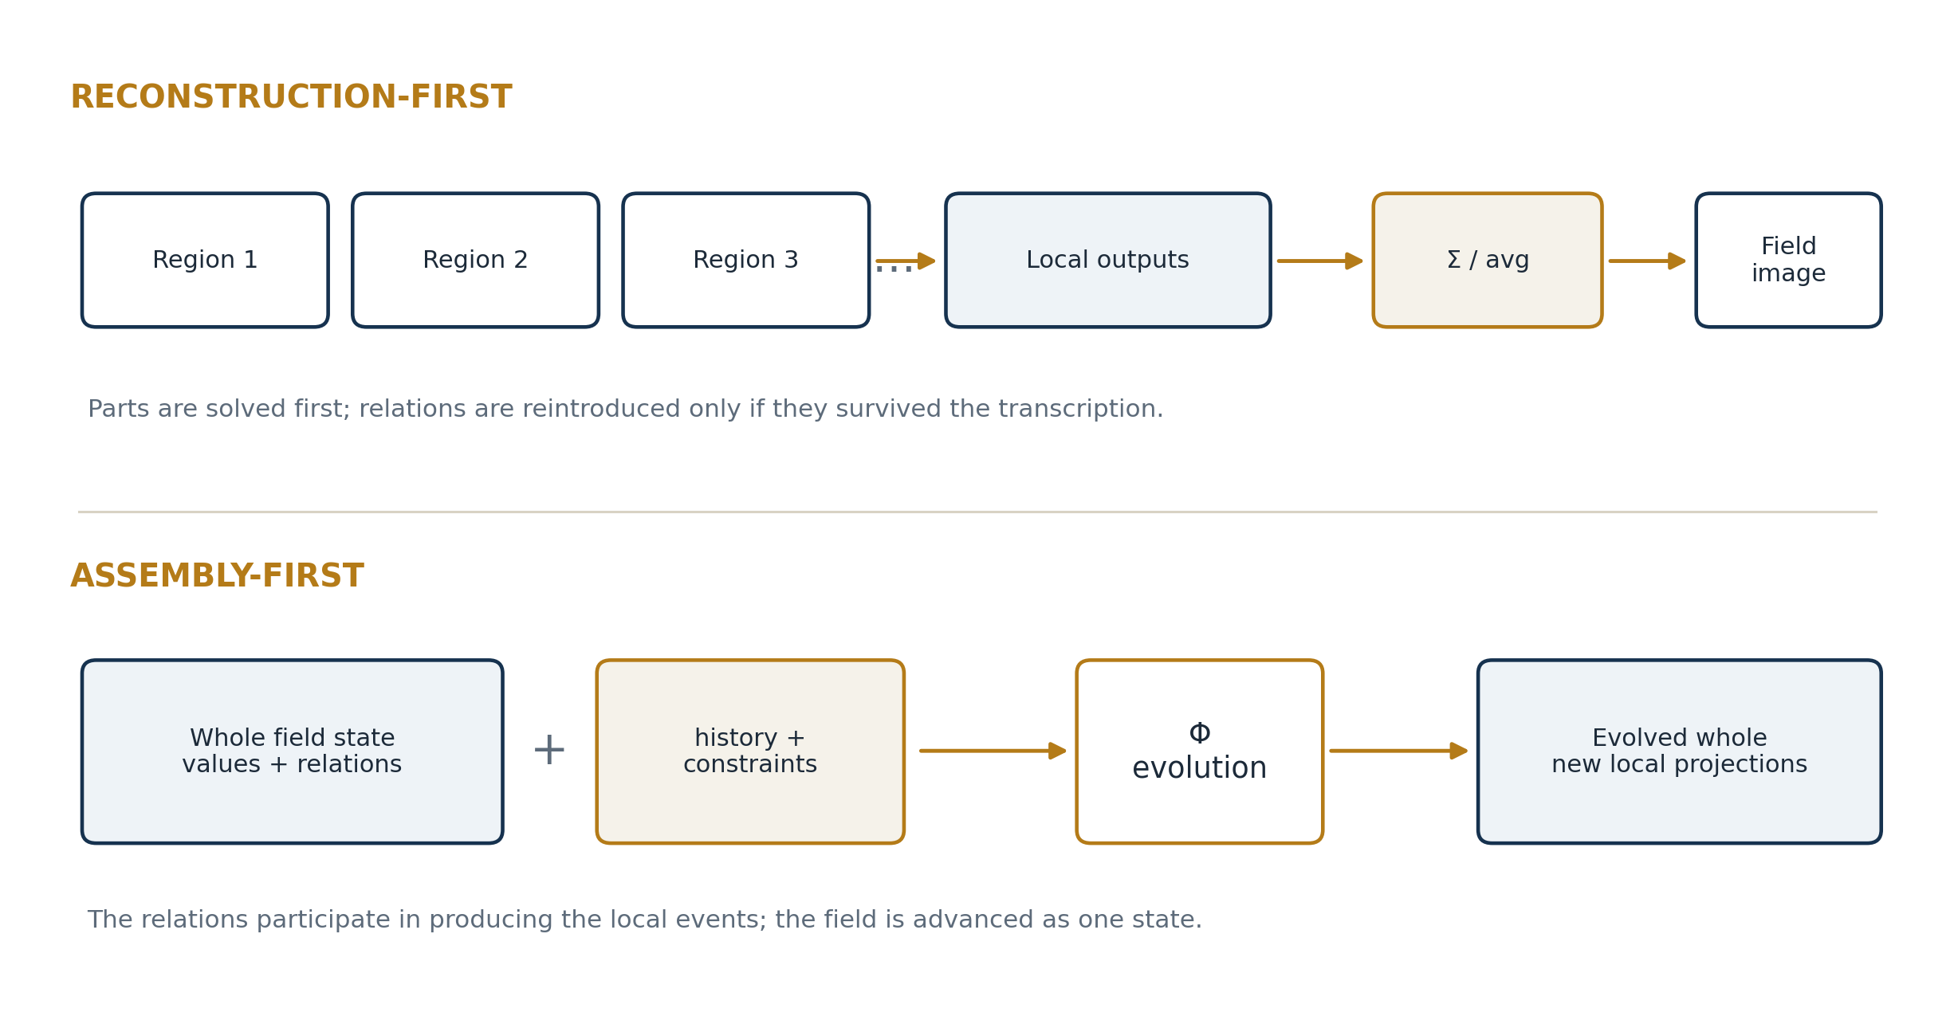
Figure 1. Reconstruction combines local outputs; assembly allows relations and history to participate in producing those outputs.

The alleged structural flaw
The flaw argued here is not that mathematics lacks fields, topology, graphs, tensors, operators, or nonlocal correlations. Mathematics contains all of these. The flaw is an architectural failure mode: a representation is permitted to discard relational distinctions during decomposition, and a later aggregation is then treated as though it had restored the whole. When the discarded distinctions affect evolution, the reconstructed object is not dynamically equivalent to the original field.
Structural flaw of decomposition-first mathematics
It permits “what can be read separately” to stand in for “what exists together,” even when togetherness changes what the parts can become.
PROPOSED | This paper identifies the repeated use of relationally incomplete transcription as a structural flaw in decomposition-first mathematical practice, not as a limitation of every mathematical formalism.
SECTION TWO

Mr. Crowley and the hotel field
Mr. Crowley is the caretaker of a hotel with twenty rooms. Some bulbs are broken. Some flicker. Some rooms are dim. Some are already bright. Doors may be open or closed; walls absorb or reflect; corridors connect rooms in different ways. Crowley carries one flashlight and completes his work over a week.
The easy description is room-by-room. For room i, record the initial illumination Rᵢ, the flashlight contribution Fᵢ, and the final illumination Rᵢ′:
Rᵢ′ = Rᵢ + Fᵢ.
Repeat the calculation twenty times and summarize:
R̄′ = (1/20) Σᵢ Rᵢ′.
This answer may be numerically correct and still fail to state the event Crowley actually managed. A bright room can receive more photons while gaining no useful visibility. A dark room can receive less total light yet become inspectable. A mirror can redirect the beam so that a change in one room is produced by a relation originating elsewhere. A closed door can make a geometrically pointed beam causally irrelevant to the room behind it.
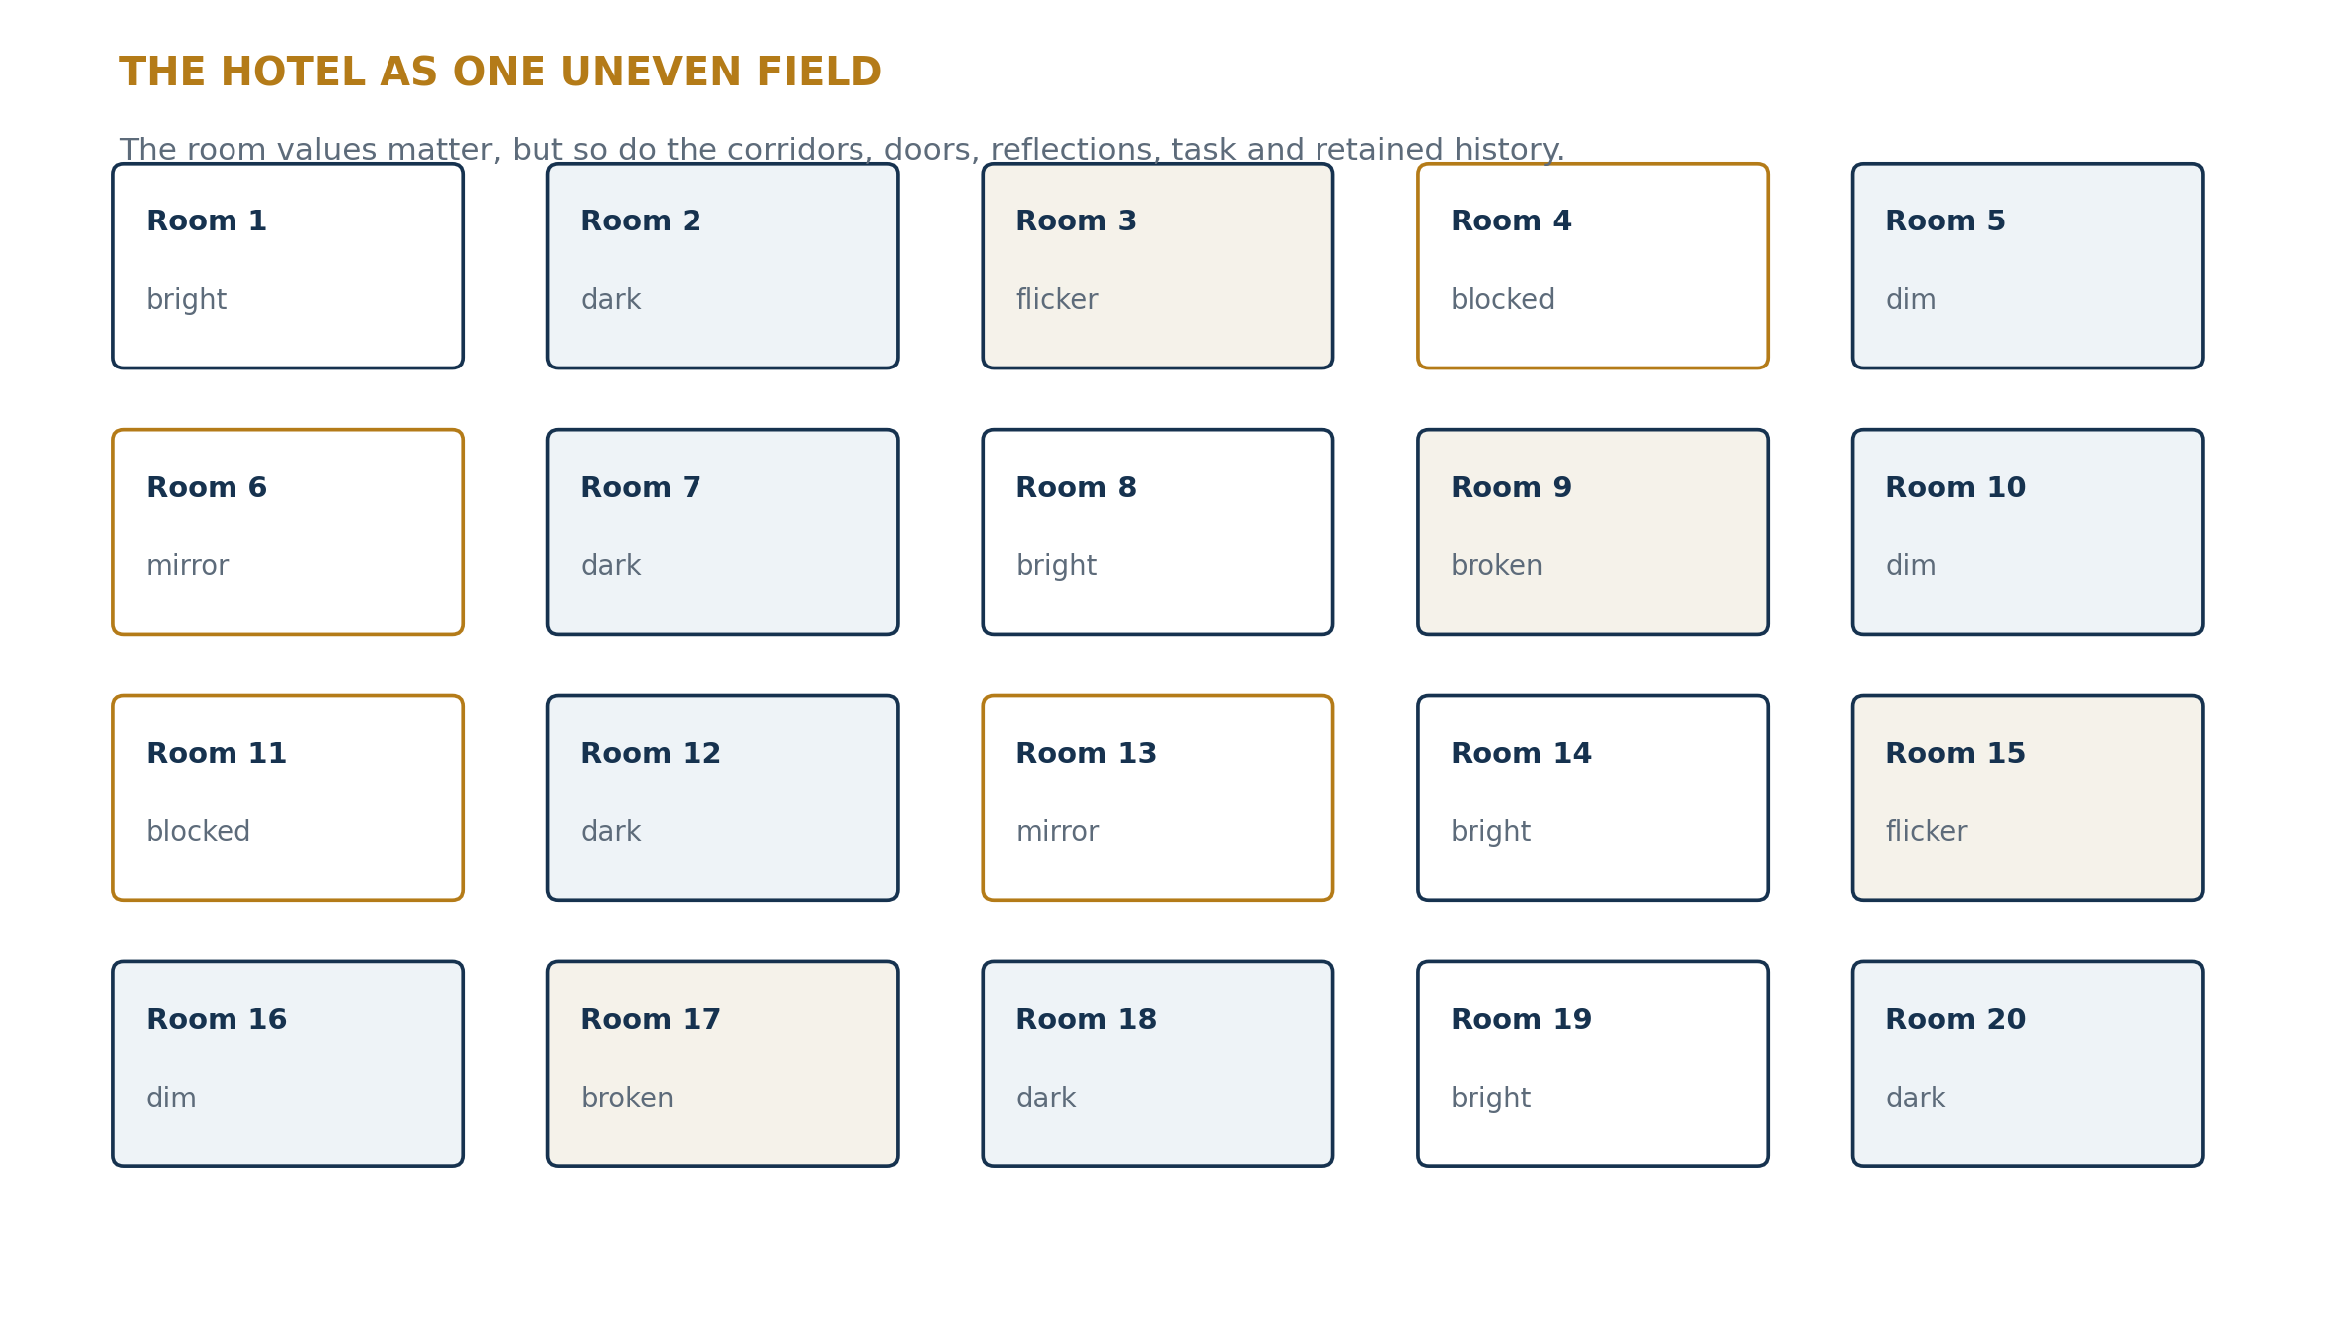
Figure 2. The hotel is one uneven field. Local room values do not by themselves specify reachability, reflection, task, or history.

The field of usefulness
For a task τ, define the change made by the flashlight in room i as
Δᵢ(F | τ) = Uᵢ(Rᵢ + Fᵢ, τ) − Uᵢ(Rᵢ, τ).
The vector Δ = (Δ₁, …, Δ₂₀) is not the same object as the final brightness vector. It records where the incoming action made a task-relevant difference. But even this vector is only a snapshot unless the hotel’s connectivity, causal pathways, and retained changes are included in the state that produces the next update.
The hotel example is deliberately visible. Crowley can inspect the corridors and manually explain the omitted relations. That makes it a good teaching analogy but a weak proof of necessity. The deeper problem appears when the receiver cannot return to the hotel and cannot see anything the algebra failed to preserve.
SECTION THREE

Glorpnorp and the requirement of lossless translation
At the end of the week, Crowley must transfer responsibility to an alien named Glorpnorp. Glorpnorp is deaf and blind and has no independent sensory channel except touch. Through a tactile algebraic interface, he can read equations, predicates, operators, and calculus. He cannot inspect the hotel, infer a corridor from sight, hear a flickering ballast, or notice that a numeric report “looks wrong.” Whatever Crowley fails to encode is unavailable.
The comic surface of the thought experiment imposes a severe formal condition. Glorpnorp is a receiver with no side information. The algebra must carry the state, not merely prompt a human reader to reconstruct it from shared experience.

The Crowley–Glorpnorp transmission problem
Problem statement
Construct an algebraic transcript that allows Glorpnorp to answer every relevant question Crowley could answer from the completed hotel state, and to evolve that state correctly under the same future interventions, without seeing the hotel.
A weak transcript might contain only a vector of room brightnesses:
b = (b₁, b₂, …, b₂₀).
This is enough to answer “what brightness was measured in each room?” It is not enough to answer “which bulb should be replaced?”, “which dark room is unreachable because its door is blocked?”, “where will a beam go after striking room 6’s mirror?”, or “which room became useful because of Crowley’s action?” Those questions require distinctions that are not numeric brightness values.
The transcript must therefore encode more than quantities. It must encode the logic that makes the quantities states of this system rather than an anonymous list of numbers.

Translation without sensory repair
Human mathematical communication often relies on silent repair. A diagram, physical intuition, conventional background, or visual inspection supplies relations that the equations omit. Glorpnorp forbids that repair. If two distinct hotel conditions generate the same algebraic transcript, he must treat them as the same state. If they later respond differently, the transcript—not Glorpnorp—was incomplete.
τ(𝓗₁) = τ(𝓗₂) while Φ(𝓗₁, I) ≠ Φ(𝓗₂, I).
This is the exact point at which missing meaning becomes missing dynamics.
SECTION FOUR

Formal definitions

Definition 1 — Complete field state
A complete field state is represented as
𝓕 = (V, 𝓒, K, H, Q).
- V: locally measurable values or component states.
- 𝓒: relations, adjacency, orientation, phase, correlation, and other couplings.
- K: constraints determining which transitions are admissible.
- H: retained history where history affects later response.
- Q: task-relative or question-relative predicates required by the intended use of the model.
The tuple is not claimed to be the only possible state architecture. It states the minimum lesson: a field may contain distinctions that are neither reducible to local values nor reconstructible from them.

Definition 2 — Transcription
A transcription is a map
τ : X → A
from possible physical or conceptual states X into algebraic descriptions A. The transcription can be numeric, symbolic, logical, geometric, or mixed.

Definition 3 — Reconstruction
A reconstruction is a map R : A → X̂ that produces an estimated whole from the transcript. Reconstruction asks whether the original state can be inferred after transcription.

Definition 4 — Dynamical sufficiency
Let Φᵤ be physical evolution under an intervention u. A transcription τ is dynamically sufficient for a family of interventions U if there exists an algebraic evolution Ψᵤ such that, for every x and every u in U,
τ(Φᵤ(x)) = Ψᵤ(τ(x)).
The algebra need not reproduce every inaccessible microscopic feature. It must preserve every distinction that changes the future at the level the transcript claims to describe.

Definition 5 — Logical state distinction
A logical state distinction is a predicate or relation that separates states which may share the same numeric values but admit different transitions. Examples include Broken(Bulb₃), Connected(Room₂, Hall), Blocked(Door₄), Reflects(Wall₆), and RequiredFor(Room₁₂, Inspection). Logic here is not commentary placed beside the algebra. It determines which algebraic state is present and which updates are valid.
SECTION FIVE

The Field Assembly Failure Theorem
Theorem 1 — Field Assembly Failure
Let two globally distinct fields have the same decomposed local transcript but different relational organization. If that organization changes their evolution under the same input, no reconstruction using only the local transcript can correctly represent both fields.

Formal statement
Let P be a decomposition or local transcription. Suppose there exist 𝓕 and 𝓖 such that
𝓕 ≠ 𝓖, P(𝓕) = P(𝓖),
but for some intervention I,
Φ(𝓕, I) ≠ Φ(𝓖, I).
Then no deterministic reconstruction A operating only on P(·) can reproduce the correct next state of both systems.

Proof
Because P(𝓕) = P(𝓖), the reconstruction receives exactly the same input for both fields. A deterministic map must therefore return the same output:
A(P(𝓕)) = A(P(𝓖)).
But the correct evolutions differ. The single reconstructed output cannot equal both Φ(𝓕, I) and Φ(𝓖, I). It is therefore wrong for at least one field. The missing relational distinction was not hidden inside the local values; it was removed by P. Aggregation cannot recover a distinction that its input does not contain. ∎
PROVED | Relationally conditioned fields cannot be uniquely assembled from relationally incomplete transcripts.

Corollary 1 — Appearance is weaker than generative structure
A reconstruction may match every measured local output at one time while failing to preserve the organization that determines later outputs. Therefore a match to the present field image does not prove a match to the field’s generative state.
P(𝓕(t)) = P(𝓖(t)) does not imply P(𝓕(t+1)) = P(𝓖(t+1)).

Corollary 2 — The lost relation cannot be added afterward
If a relation participates in producing local outcomes, it must be present before or during the update. Adding a label after the local calculations are complete may describe the outcome, but it does not retroactively make the relation causal in the model.
In one sentence
A sum of completed events is not the field that made the events possible.
SECTION SIX

The Evolution-Preserving Transcription Criterion
The first theorem proves failure when two distinct wholes collapse to the same transcript. The positive requirement is stronger than ordinary reconstruction. Crowley needs an algebra that Glorpnorp can evolve.
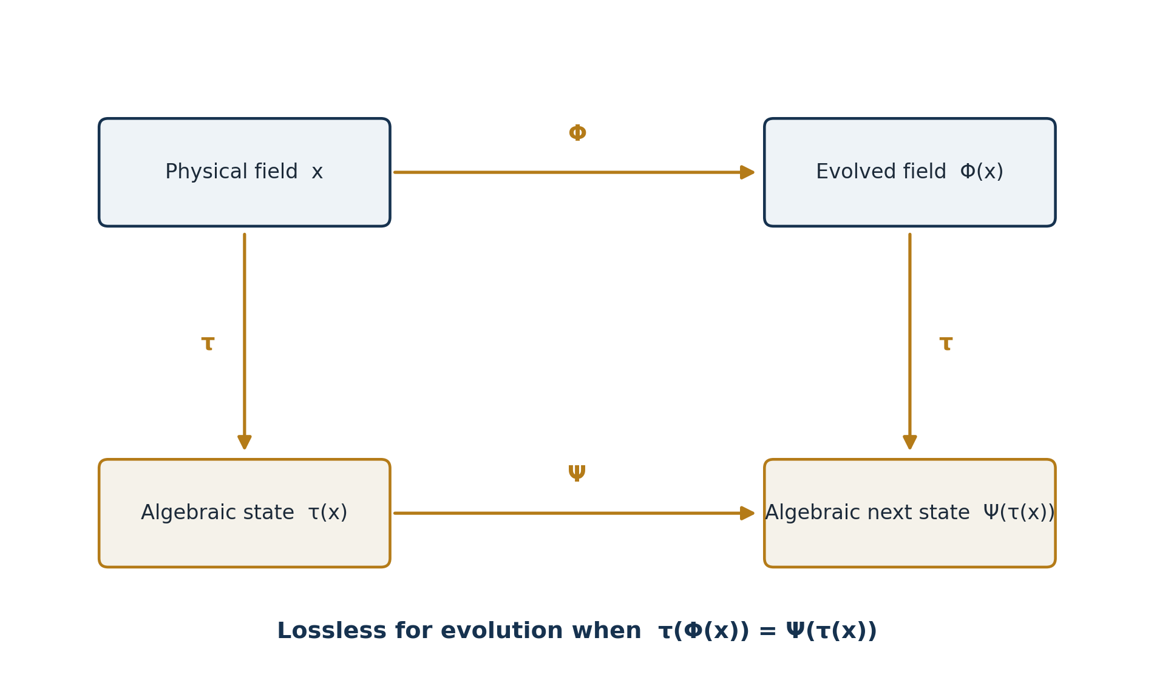
Figure 3. The physical update and algebraic update must agree after translation.
Theorem 2 — Evolution-Preserving Transcription
A transcription τ is dynamically sufficient for an evolution Φ exactly when an algebraic update Ψ can be defined so that translating after physical evolution gives the same algebraic state as evolving after translation.
τ ∘ Φ = Ψ ∘ τ.

Equivalent criterion
Define x ~τ y whenever τ(x) = τ(y). An algebraic update Ψ exists if and only if the equivalence classes induced by τ are stable under Φ:
x ~τ y ⇒ Φ(x) ~τ Φ(y).

Proof
If Ψ exists and τ(x) = τ(y), then Ψ(τ(x)) = Ψ(τ(y)). By commutation, τ(Φ(x)) = τ(Φ(y)); therefore equivalent transcripts remain equivalent after evolution. Conversely, suppose transcript-equivalent states always remain transcript-equivalent. Define Ψ on an algebraic state a by choosing any x with τ(x) = a and setting Ψ(a) = τ(Φ(x)). The stability condition guarantees that the result does not depend on which representative x was chosen. Therefore Ψ is well defined and the diagram commutes. ∎
PROVED | Lossless transcription for a claimed scale of evolution is equivalent to preserving every distinction that can split into different algebraic futures.

What Glorpnorp requires
Glorpnorp does not need a duplicate hotel made of symbols. He needs a sufficient algebraic state. Two physical details may be merged when they never produce a relevant algebraic difference under the allowed interventions. They may not be merged merely because they look numerically similar now.
This criterion turns “meaning” into a test. A distinction is meaningful to the model when removing it makes the algebraic future ambiguous.
SECTION SEVEN

Why logic must define algebraic states
Numbers state magnitudes. They do not always state what those magnitudes are doing in the system. A room brightness of 0.2 may mean a broken bulb, a closed shutter, an absorbing wall, a switched-off source, a blocked corridor, or a room deliberately kept dark. These physical conditions can share the same measured value and respond differently to the same intervention.
Theorem 3 — Logical State Completion
If two states share the same numeric transcript but respond differently to an allowed intervention, any dynamically sufficient algebra must include at least one additional distinction—logical, relational, historical, or geometric—that separates them.

Formal statement and proof
Let m : X → ℝⁿ be a numeric measurement. Suppose m(x) = m(y), but for some intervention u,
m(Φᵤ(x)) ≠ m(Φᵤ(y)).
A state representation containing only m cannot define a unique next measured state, because the same algebraic input m(x) would require two outputs. Therefore a sufficient state encoding must refine m by adding some distinction d with d(x) ≠ d(y). The distinction may be a predicate, relation, constraint, phase, topology, or retained record. ∎
PROVED | Logic is required in the algebra whenever state identity depends on causal role rather than magnitude alone.

Logic is not an annotation
In this paper, “logic” does not mean an English explanation written beside an equation. It means the formal distinction of entities, relations, conditions, and allowable consequences. The predicate Broken(Bulb₃) changes the response to Replace(Bulb₃). Connected(Room₂, Hall) changes whether a beam can reach Room₂. RequiredFor(Room₂, Inspection) changes whether illumination counts as task success. These statements determine the domain and update rules of the algebra.

A compact logic-state schema
A(t) = (N, E, V, P, K, H, ℛ).
- N: named or indexed distinctions—rooms, doors, sources, surfaces, tasks.
- E: relational edges—connected to, blocks, reflects into, belongs to.
- V: numeric values—brightness, power, angle, time, response.
- P: predicates—dark, broken, required, active, reached, recorded.
- K: constraints—walls cannot transmit, closed doors block, mirrors redirect.
- H: retained record—repairs performed, paths already tested, changes that persist.
- ℛ: update rules that transform the full algebraic state.
The state is algebraic because each component has formal identity and update. It is logical because those identities and updates are constrained by propositions and relations, not merely by arithmetic magnitude.

The seven-doing grammar
Unified Mechanics already describes a system through an ordered grammar: distinguish, hold, close, answer, change, order, record. Applied to algebraic state transmission:
1. Distinguish the entities and state alternatives that must not be collapsed.
2. Hold their values, relations, and constraints as one present state.
3. Close the state under the rules required to make an update well defined.
4. Answer an intervention according to the complete present condition.
5. Change the relevant local and relational components.
6. Order those changes so that later updates inherit the correct causal sequence.
7. Record the distinctions that remain part of the next state.
A state description that omits any one of these may still be readable as a snapshot. It is not automatically sufficient as an evolving algebra.
SECTION EIGHT

A complete Crowley–Glorpnorp transmission
Crowley’s task is now formal. He must package the hotel so that Glorpnorp can answer both descriptive and counterfactual questions. The transcript must not merely say what Crowley observed; it must say enough to determine what would happen under future actions.

The weak transcript
Tweak = { b₁, b₂, …, b₂₀ }.
This transcript supports queries about measured brightness. It does not identify why a room is dark, whether the darkness can be changed by replacing a bulb, whether a beam can reach the room, or which previous repair changed the present state.

The assembled transcript
Tfull = (Rooms, Connections, Devices, Surfaces, Values, Predicates, History, Rules, Tasks).
A small fragment might read:
Algebraic statement | What it preserves
Room(R7) | R7 is an identified region of the hotel.
Connected(Hall, R7) | A path relation exists; the room is not isolated.
Closed(Door7, t) | The path is presently blocked.
Dark(R7, t) ∧ BulbBroken(B7, t) | The same brightness value is assigned a causal state.
Carries(Flashlight, Crowley, t) | The source is available at Crowley’s present position.
Task(InspectPanel, R7) | Visibility is evaluated relative to a named requirement.
Repaired(B7, t−1) | A retained change may affect present reliability.
Reach(F, R7, t) ⇔ Path ∧ ¬Blocked | The update is constrained by hotel structure.
Table 1. A logic-state transcript preserves causal role, not only measured magnitude.

A rule for useful illumination
Useful(F, R, t | τ) ⇔ Reach(F, R, t) ∧ Need(R, t | τ) ∧ Response(R, F, t) > 0.
This rule does not give the flashlight intention. It defines success relative to Crowley’s stated task. A photon or beam can propagate without satisfying Useful. The hotel supplies the relations and conditions through which direction becomes an effective change.

A rule for the next state
A(t+1) = ℛ[A(t), I(t)].
The rule ℛ updates numeric values, predicates, relations, and record together. Opening Door7 changes Closed(Door7) to Open(Door7), changes reachability, may change the beam path, may illuminate R7, and records that the intervention occurred. The new local brightness is one consequence of the full update, not the entire update itself.

What Glorpnorp can now do
- Identify which rooms remain unusable and why.
- Predict which rooms will change under a named intervention.
- Distinguish redundant illumination from necessary illumination.
- Trace a local outcome to the field relations that made it available.
- Advance the hotel state without relying on visual intuition.
- Audit which information was observed, inferred, proposed, or retained as history.
The success of the transcript is not that it contains more words. It is that algebraic evolution becomes single-valued for the relevant questions.
SECTION NINE

Systems whose missing relations cannot be seen afterward
The hotel analogy becomes necessary rather than merely convenient when the omitted relation is not recoverable by ordinary inspection. Three examples show increasing strength: a spatial network, an optical wavefront, and a globally correlated quantum state.

9.1 Spatial example: identical rooms, different corridors
Let five regions have identical local values in two spatial systems:
V_A = V_B = (1, 0, 0, 0, 0).
System A connects the regions in a line: 1—2—3—4—5. System B connects region 1 only to region 5, while regions 2, 3, and 4 form a separate chain. A local-value transcript records the same state in both systems. Under diffusion or signal propagation, the next values differ because the adjacency matrices differ:
V′ = V + α L V,
where L is the graph Laplacian. The same V with different L produces different V′. The field state is therefore not V alone but at least (V, L). The missing information is spatial relation itself.
Recovered information
An assembly state identifies not only what value exists at each place, but which places can act on which others.

9.2 Optical example: identical intensity, different wavefront
A coherent optical field can be written
E(x,y) = A(x,y)e^{iφ(x,y)}.
An intensity-only transcription records
I(x,y) = |E(x,y)|² = A(x,y)².
Two fields can have identical intensity at every recorded point while carrying different phase functions φ. After further propagation or passage through a lens, they can focus, spread, or interfere differently. The intensity image was accurate. It was not dynamically complete. The phase relation did not decorate the local amplitudes; it determined their collective future.
This example makes the field-assembly claim concrete. A canvas of local brightness can be perfectly reconstructed while the wave that produced the canvas has been lost in transcription.

9.3 Quantum example: the relation is the only difference
Consider the two three-part states
|Ψ₊⟩ = (|000⟩ + |111⟩)/√2, |Ψ₋⟩ = (|000⟩ − |111⟩)/√2.
Every one-part reduced state is identical for the two cases. Every two-part reduced state is also identical:
ρᵢ = ½(|0⟩⟨0| + |1⟩⟨1|),
ρᵢⱼ = ½(|00⟩⟨00| + |11⟩⟨11|).
Yet the complete states differ in their global phase relation. A three-part observable separates them:
⟨X⊗X⊗X⟩Ψ₊ = +1, ⟨X⊗X⊗X⟩Ψ₋ = −1.
No addition of the identical one-part and two-part transcripts can recover the sign. It was never a property of any isolated part. It was a property of the assembly. This is the strongest form of the theorem: the globally distinguishing information can be absent from every permitted local transcript while remaining physically available to a joint operation.
ILLUSTRATIVE | The spatial, optical, and quantum constructions do not prove Unified Mechanics as a physical theory. They prove that relational transcription loss is mathematically possible and can alter prediction.
SECTION TEN

Unified Mechanics formulation
A World of Distinctions begins from a system as differences held together by relations, following a rule. It then describes the ordered doings distinguish, hold, close, answer, change, order, and record. The present paper applies that grammar to field representation: an algebraic state must preserve the distinctions and relations through which the field answers an intervention and records the result.

Direct, related, held
In the hotel, the flashlight is the direct outward action. The room and hotel configuration are the held condition. The boundary interaction—doorway, wall, mirror, receiver, task—is the related term through which the outward action becomes a local event. The relation is not calculated after the direct and held terms have independently finished. It is part of the operation that determines their outcome.
Event = Direct action ⊗ Relational resolution ⊗ Held condition.
The symbol ⊗ is used here to emphasize dependence, not to assert one fixed tensor product for every application. The claim is structural: removing the relation can identify states that the system itself treats differently.

The assembled evolution field
𝓕(t+1) = Φ[V(t), 𝓒(t), K(t), H(t), Q(t), I(t)].
The field’s local values at the next step are read from this evolved whole. The method is therefore not “calculate every photon and average them” versus “ignore photons and speak vaguely about wholes.” The method is to make the state rich enough that local trajectories and global conditions are generated by one algebraic evolution.

Meaning as algebraic consequence
The word meaning is often treated as foreign to physical mathematics because it suggests human interpretation. Here it is given an operational definition. A distinction has meaning relative to a model when it changes which propositions become true, which transitions are allowed, or which future transcript is produced.
Meaningₘ(d | u) ⇔ removing d makes Ψᵤ ambiguous or changes its result.
The universe need not intend the photon’s path. The field supplies the structure through which the path has a determinate consequence. Direction carries an outward possibility; relational structure determines what that possibility becomes.

Logical algebra as loss-control
Unified Mechanics therefore claims that logic belongs inside state algebra. Predicates and relations mark distinctions that quantities alone may collapse. Update rules carry those distinctions through time. Record prevents a later state from being mistaken for an identical-looking state with a different causal history. The purpose is not to replace calculus but to specify what the calculus is evolving.
PROPOSED | A dynamically complete Unified Mechanics field should be represented as an evolving logical algebra whose numeric, relational, and historical components are updated together.
SECTION ELEVEN

Consequences, limits, and tests

11.1 Consequence for modelling
Before solving local equations, a model should state the equivalence relation implied by its transcription: which physically different states are being declared algebraically identical? It should then test whether those equivalence classes remain stable under the intended evolution. If not, the state variables are incomplete.
1. Specify the questions and interventions the model must support.
2. Identify the distinctions, relations, constraints, and history that can change the answers.
3. Construct the transcription τ.
4. Search for states x and y with τ(x) = τ(y).
5. Apply the same allowed intervention to both.
6. If their algebraic futures differ, refine the state description.
7. Only then perform decomposition, approximation, or aggregation.

11.2 Consequence for measurement
Measurement does not become useless because it is partial. It becomes honest about its claim. An intensity map is a complete intensity transcript, not necessarily a complete optical field. A list of local marginals is a complete list of those marginals, not necessarily a complete joint state. The theorem demands that the named object match the information actually retained.

11.3 Consequence for machine-readable science
Glorpnorp can be read as an alien, a computer, a future scientist, or any receiver lacking the sender’s tacit context. A model intended for autonomous reasoning must encode the ontology and transition logic that a human silently supplies. Otherwise the machine receives numbers that are syntactically valid but causally underdetermined.

11.4 What the theorem does not claim
- It does not claim that every system is irreducibly holistic.
- It does not reject decomposition when the retained variables are sufficient.
- It does not claim that all microscopic information must be preserved.
- It does not claim that logic replaces measurement, differential equations, or probability.
- It does not recover information after a transcription has physically destroyed it.
- It does not establish the proposed physical identifications of Unified Mechanics merely by proving the information-loss theorems.
The theorem permits coarse-graining. It prohibits only coarse-graining that identifies states whose relevant futures differ, while still claiming to predict those futures.

11.5 Falsification and failure conditions
The proposed Unified Mechanics prescription fails to add value in a domain when a conventional state representation already satisfies the evolution-preserving criterion for every relevant intervention. In that case the required relational logic is already present, whether written as geometry, boundary conditions, gauge structure, a density operator, a graph, a state machine, or another formal object. The paper’s criticism applies only when the state is transcribed more weakly than the dynamics require.
A specific assembly model fails if it introduces predicates that do not improve prediction, cannot be operationally distinguished, or merely rename quantities without changing the equivalence classes of states. The logic must earn its place by resolving an otherwise ambiguous evolution.
TESTABLE | Given a proposed transcript, search for transcript-identical states that diverge under an allowed update. Finding such a pair proves the transcript dynamically incomplete; failing to find one across the model’s full state space supports sufficiency for that scope.
SECTION TWELVE

Conclusion and theorem ledger
Mr. Crowley can describe the hotel to another human with an incomplete equation because the human shares sight, space, language, and practical expectation. Glorpnorp removes those hidden channels. The algebra must now do the full work of state transmission. A list of room values is not enough when corridors, doors, causal roles, tasks, and retained changes determine what those values can become.
The resulting distinction is exact. Reconstruction attempts to infer a whole from a transcript of completed parts. Assembly encodes the distinctions and relations that participate in producing the parts and advances them as one state. A transcript is adequate not because it reproduces the present appearance, but because it preserves the future distinctions the model claims to predict.
This is why logic belongs in algebraic state definition. Two equal numbers can be unequal states. A broken bulb and a switched-off bulb may share brightness while admitting different repairs. Two optical fields may share intensity while carrying different phase. Two quantum systems may share every permitted local transcript while differing in a global relation. The lost information is not an extra story told about the field. It is part of the field’s ability to evolve.
Final statement
A field is assembled when its values, relations, constraints, history, and admissible transitions remain one evolving algebra. It is merely reconstructed when the relations are discarded, the parts are solved, and a global image is produced afterward.

Theorem ledger
Result | Grade | Content
Field Assembly Failure Theorem | PROVED | A relationally incomplete local transcript cannot uniquely reproduce fields whose omitted relations change evolution.
Evolution-Preserving Transcription Criterion | PROVED | A transcription is dynamically sufficient exactly when physical and algebraic evolution commute at the claimed scale.
Logical State Completion Theorem | PROVED | Numerically identical states that respond differently require an additional algebraic distinction.
Unified Mechanics field prescription | PROPOSED | Represent the field as an evolving logical algebra of values, relations, constraints, history, questions, and rules.
Structural flaw claim | PROPOSED | Decomposition-first practice is flawed when it treats relationally incomplete reconstruction as assembly.
Table 2. Claims kept in grade rather than silently mixed.

Compact lecture form
Crowley can see the hotel. Glorpnorp can see only the algebra.
If the algebra tells Glorpnorp what every room looked like but not why it was that way, how the rooms were connected, what could change them, or what Crowley’s actions left behind, then the hotel has been reconstructed as a picture but not transmitted as a system.
Snapshot preserved ≠ evolution preserved.
Local values + missing relations ≠ assembled field.
τ(Φ(x)) = Ψ(τ(x)) is the test.
SECTION APPENDIX A

Minimal algebraic package for the hotel
The following schema is intentionally compact. It is not a software specification; it demonstrates the kinds of distinction a lossless state requires.

Entities
N = {Hotel, Hall, R₁…R₂₀, Door₁…Door₂₀, Bulb₁…Bulb₂₀, Flashlight, Crowley, Glorpnorp}.

Relations
E = {Inside(Rᵢ, Hotel), Connects(Doorᵢ, Hall, Rᵢ), ReflectsInto(Sⱼ, Rₖ), Carries(Crowley, Flashlight)}.

Numeric values
V = {Brightness(Rᵢ,t), Power(Flashlight,t), Angle(Sⱼ), Reliability(Bulbᵢ,t)}.

Predicates
P = {Open, Closed, Broken, Flickering, Dark, Reached, Needed, Useful, Repaired, Recorded}.

Rules
Reach(F,R,t) ⇔ ∃ path p from F to R with every blocking predicate false.
Useful(F,R,t|τ) ⇔ Reach ∧ Need ∧ PositiveResponse.
Record(t+1) = Record(t) ∪ {distinctions produced at t}.

Transmission test
For every allowed intervention u: τ(Φᵤ(𝓗)) = Ψᵤ(τ(𝓗)).
When this equality fails, Crowley and Glorpnorp do not possess the same operational hotel, even if every listed number agrees.
SECTION APPENDIX B

Relation to A World of Distinctions
This paper extends the monograph’s system grammar into a criterion for mathematical representation. The monograph states that meaning belongs to the whole formed by ordered relations rather than to isolated words, and that a system must distinguish, hold, close, answer, change, order, and record. The present construction asks what algebra must preserve so that those doings survive translation.
The direct–related–held reading is used here as a structural interpretation: outward action, relational resolution, and retained condition. No new physical identification is proved merely by the algebraic theorems. The proved content concerns transcription, equivalence classes, and evolution. The physical reading remains proposed and must be tested in each domain.

Reference
Shields, Joseph. A World of Distinctions: How a Sentence, Asked to Describe Itself, Becomes a Universe. Unified Mechanics, Corpus Edition, 2026.

